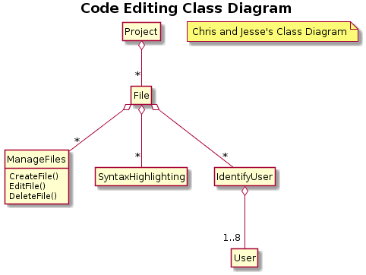

hide circle

hide empty methods

hide empty fields

title <b> Code Editing Class Diagram </b>

Project o-- "\*" File

note "Chris and Jesse's Class Diagram" as N1

File o-- "\*" ManageFiles

File o-- "\*" SyntaxHighlighting

File o-- "\*" IdentifyUser

ManageFiles : CreateFile()

ManageFiles : EditFile()

ManageFiles : DeleteFile()

IdentifyUser o-- "1..8" User